**Personal Touch Aesthetic**

## Your Destination for Safe and Effective Cosmetic Treatments in Tucson, AZ

Welcome to Personal Touch Aesthetic, where we prioritize your safety and satisfaction. Located in the heart of Tucson, AZ, our clinics are dedicated to providing the highest quality cosmetic treatments, including Botox, Lip Fillers, PRP, Sculptra, Jeuveau, and Dysport injections.

**Website:** <https://personaltouchaesthetic.com/>

**Phone:** +1 208-585-8492

**Location:** 7478 N La Cholla Blvd Studio 1, Tucson, AZ 85741, United States

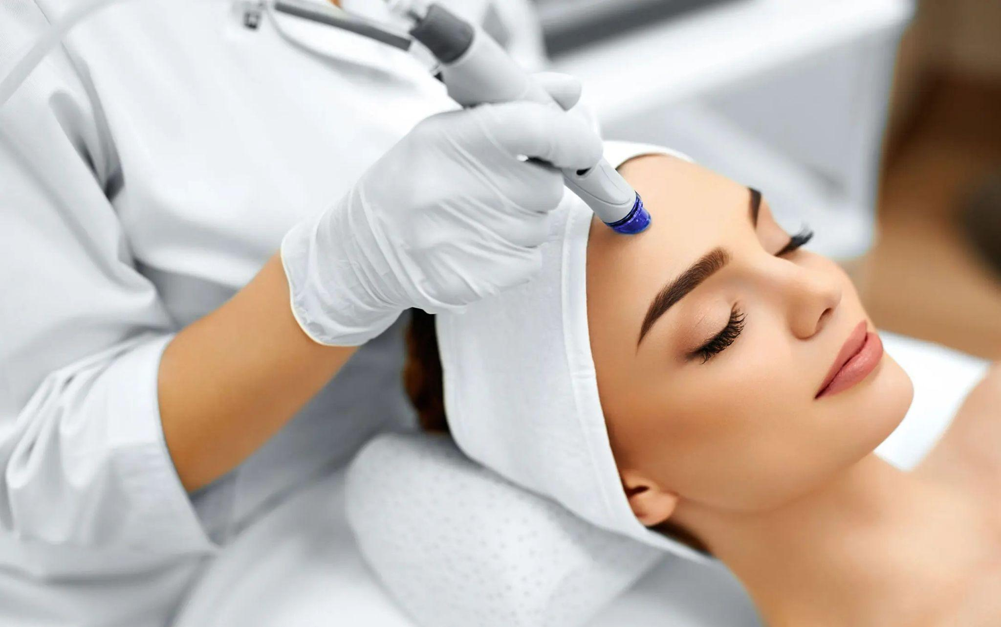

**Key Services Offered**

* **Botox Treatments:** Smooth away wrinkles and fine lines with our expertly administered Botox injections.
* **Lip Fillers:** Achieve plump, natural-looking lips with our Lip Filler treatments.
* **PRP Therapy:** Harness the power of your body's natural healing process with Platelet-Rich Plasma therapy.
* **Sculptra Injections:** Restore volume and youthfulness to your face with Sculptra injections.
* **Jeuveau Treatments:** Say goodbye to frown lines and wrinkles with our Jeuveau treatments.
* **Dysport Injections:** Reduce the appearance of dynamic wrinkles with Dysport injections.

**Commitment to Excellence**

At Personal Touch Aesthetic, we pride ourselves on delivering superior results and the highest level of patient care. Our team of medical professionals is dedicated to honestly assessing your needs and recommending the most suitable treatments for you.

**Additional Cosmetic Procedures**

In addition to our signature treatments, we offer a range of cosmetic procedures to help you look and feel your best, including:

* PRP
* Chemical Peels
* Dermaplaning
* Microneedling
* Lash and Brow Tinting
* Facials
* Dysport
* Jeuveau
* Sculptra

**Location**

Visit us at our convenient location in Tucson, AZ, and discover the Personal Touch Aesthetic difference today!

**Conclusion**

Experience the safest and most effective cosmetic treatments at [Personal Touch Aesthetic](https://maps.app.goo.gl/djWakomqFuizgo2t8). Trust us to enhance your natural beauty and boost your confidence. Schedule your appointment with us today!