Round 2 IV Wellness Solutions, LLC

## Top Reasons to Choose Round 2 IV for Your Health and Wellness Needs

Welcome to Round 2 IV, your premier health and wellness clinic in Albuquerque, NM. We

specialize in delivering the safest and most effective treatments, including Botox, Dermafuse,

Hormone Replacement Therapy, Infusions, Injections, IV Push, Oxygen Bar, Quarterly Specials,

Viora, and Weight Loss services. Our commitment to superior results and the highest level of

patient care has made us a trusted name in the health services industry. Join us on a journey to

better health and discover the transformative benefits of our comprehensive treatments

Website:<https://www.round2iv.com>

Email: [info@round2iv.com](mailto:info@round2iv.com)

Phone: +1 505-280-4363

Location: 5505 Osuna Rd NE # F, Albuquerque, NM 87109, United States

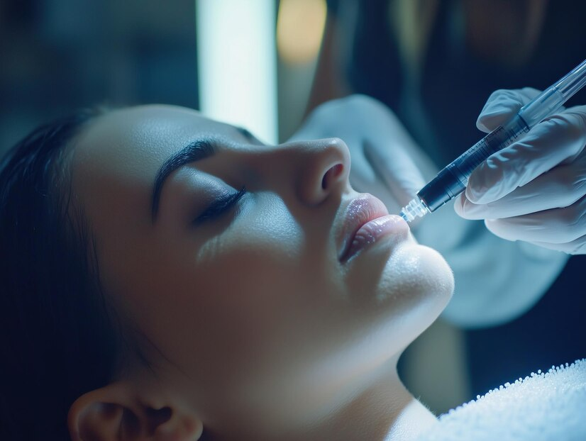

### Our Services

At Round 2 IV, we offer a wide range of health and wellness services designed to meet your unique needs:

* **Botox:** Achieve a youthful appearance with our safe and effective treatments.
* **Dermafuse:** Enhance your skin’s health and appearance with advanced Dermafuse technology.
* **Hormone Replacement Therapy:** Balance your hormones and improve your overall well-being.
* **Infusions:** Boost your health with our customized infusion therapies.
* **Injections:** Get quick and effective relief with our injection services.
* **IV Push:** Experience rapid and effective nutrient delivery with our IV Push services.
* **Oxygen Bar:** Revitalize your body with pure oxygen therapy.
* **Quarterly Specials:** Take advantage of our exclusive quarterly specials on select treatments.
* **Viora:** Rejuvenate your skin with Viora’s innovative treatments.
* **Weight Loss:** Achieve your weight loss goals with our expert guidance and support

### Why Choose Us?

* **Superior Results:** We deliver outstanding results across all our services.
* **Patient Care:** Our commitment to the highest level of patient care sets us apart.
* **Trusted Name:** We are trusted in the health services clinic industry.
* **Expert Assessments:** Our medical professionals provide honest and accurate assessments.
* **Innovative Treatments:** We use the latest technology and techniques to ensure the best outcomes.

### Patient Experience

* **Personalized Care:** Each treatment plan is tailored to your specific needs.
* **Professional Staff:** Our team of medical professionals is dedicated to your health

and well-being.

* **Comfortable Environment:** We provide a welcoming and relaxing atmosphere for

all our patients.

* **Ongoing Support:** We offer continuous support and follow-up care to ensure

lasting results.

### Conclusion: Transform Your Health with Round 2 IV

Experience the highest level of care and achieve your health goals with our comprehensive range of services. Visit [Round 2 IV in Albuquerque](https://maps.app.goo.gl/f5jh1EWKRJEVQZNn8) today and let our expert team guide you on your wellness journey