**Family Photoshoot Marbella**

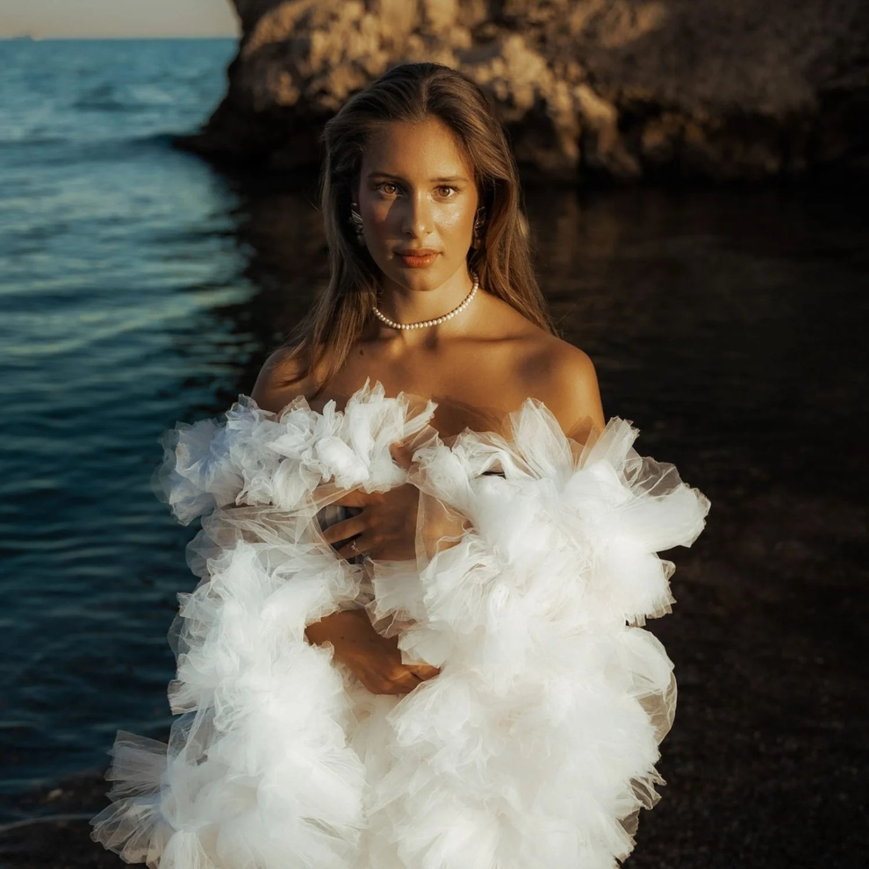

A [family photoshoot Marbella](https://justinakris.com/family-photoshoot/) captures wonderful scenes against picturesque Mediterranean landscapes. Golden beaches, historic old town pavements, and dramatic hills all come together to provide ideal Marbella settings for those memorable family photos. Unwinding and playing scenes are part of the deal, with knowledgeable experts getting families to take relaxed-pose attitudes and easy smiles. Regardless of the scene at a high-end hotel, picturesque beach, or village green, all sessions are designed to be remembered. Sunset photography adds a touch of fantasy with warm, tender light. Ideal for family holidays, special occasion moments, or Christmas photos annually, Marbella family photoshoot captures precious moments to be kept for generations.